Common multiples
Activity:

The task is to shade all the common multiples of two randomly chosen numbers (from 2 to 9).
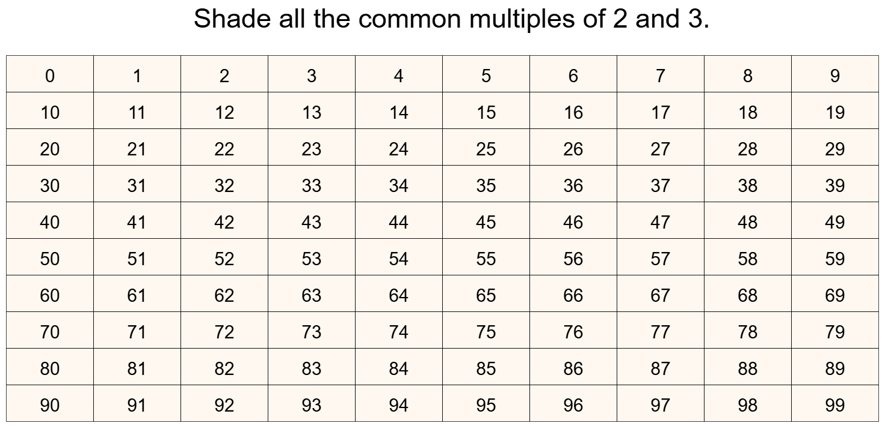

One option is to get students to call out the numbers in multiplication table 2 (in the above case), whilst you shade in the numbers as they are called out.

Another option is to use the “Shade multiplies of” option below the colour buttons at the bottom of the screen:

By clicking on the arrows, you can have the multiples of 2 shaded in the hundred square automatically. You could, also, see the multiples of 3 by this method.

Ask about the pattern created by this multiplication table. Likewise for the other multiplication table if you are showing that. It is good to spend time with just one multiplication table before considering both the tables at once.

Assuming multiplication table 2, in the above case, is highlighted, then students could call out multiplication table 3 with you shading the numbers with a different colour as they are called. When you are about to colour a number which is already coloured (i.e. it will be a common multiple of 2 and 3), then colour it with a third colour, so that the multiples stand out with this third colour.

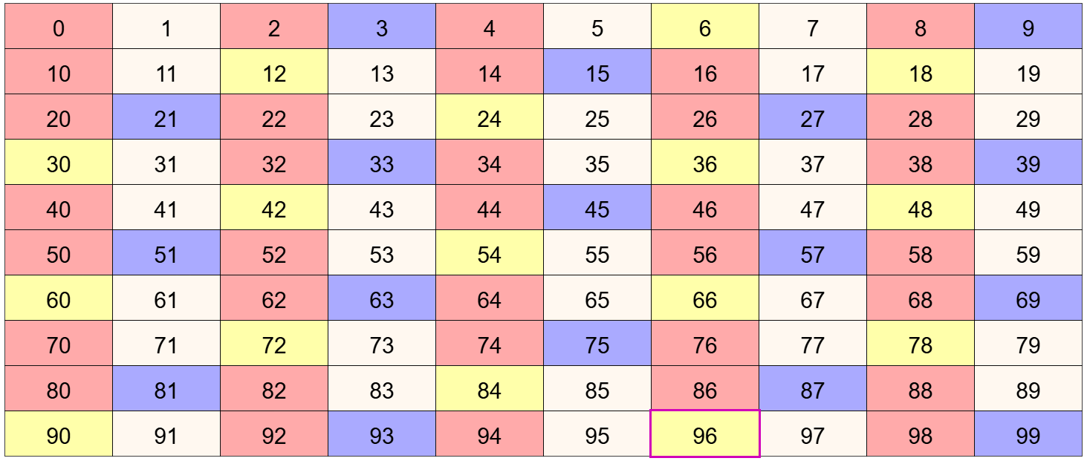

What do the students notice about the numbers coloured yellow (i.e. they were coloured for both multiplication tables)? What has this to do with the original two multiplication tables?

Pressing the  button will restart the activity with two new, randomly chosen, multiplication tables.

Teaching considerations:

It may be best to start off with two numbers which do not have a common factor, such as 2 and 3. You can keep pressing the button until you get two numbers that you want.

After students have found a rule for the common multiples of such numbers, you might bring in a case where the numbers do have a common factor, such as 4 and 6, for them to see that this situation is a little different.

There is potential for work on properties of particular multiplication tables (such as every other number is even when the multiplication table is odd, or which final digits a number in a particular multiplication table can or cannot have).

Use the question why? to see whether they can explain why any noticed rules seem to work.

Consider introducing words such as factors, multiples, common multiples, common factors, lowest common multiple, highest common factor.

In algebraic terms, the common multiples of a and b are in the following multiplication table: $\frac{a×b}{f}$ where f is the highest common factor.

