Digit count
Activity:

The hundred square is seen with all the numbers shown.

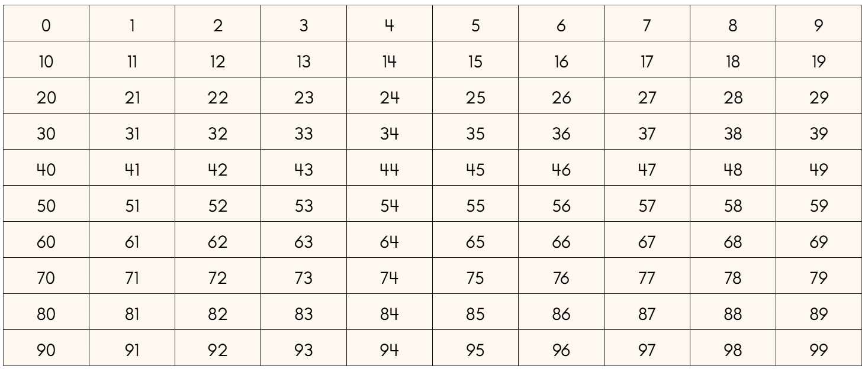

This could be projected on the screen, or a sheet with these numbers on can be printed out and given to the students (see the General Resources section for such a sheet).

An initial task is to find which digit (or digits) appear most.

A second task is to find how many digits appear in the hundred square (the number 27 would have two digits, for example).

A third task is to add up all the digits which appear (the number 27 has the digits 2 and 7 and so that number gives a sum of 9).

How do these questions change if the hundred square starts with a different number in the top-left square? For example, press on the  button and change the start number from zero to a different number, such as 23.

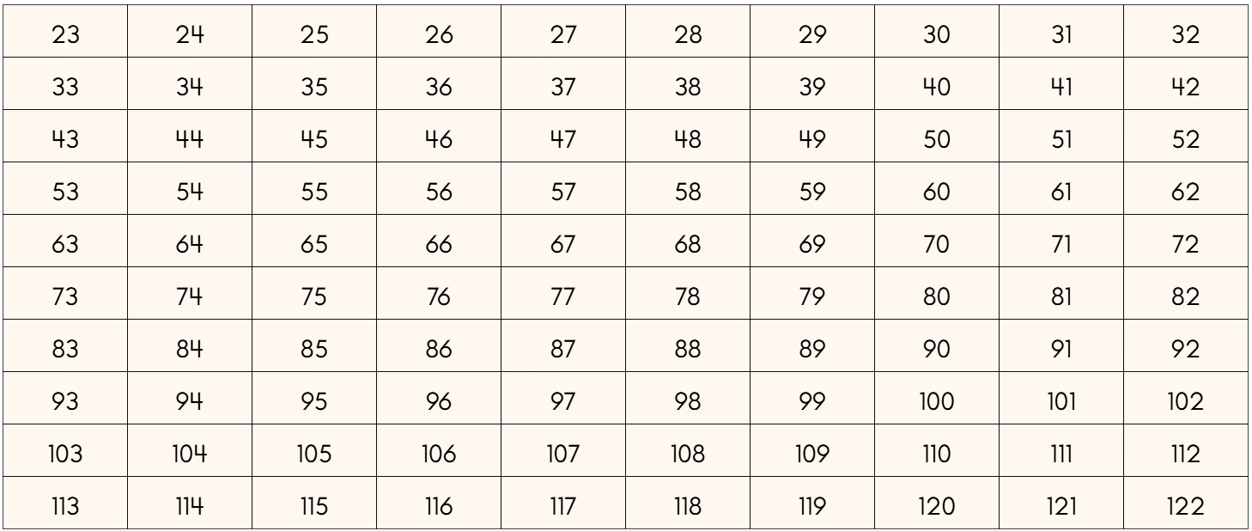

Pressing the  button will restart the activity and return the grid to the default numbers.

Teaching considerations:

One thing which might need clarifying is the difference between a number, such as 27, and a digit (27 has two digits). One feature of the activity is that there are a lot of numbers, and even more digits! So, the task can start off feeling relatively complex. However, noticing patterns can change that feeling so that something which starts off feeling complex, can become something which feels much simpler. Working mathematically by spotting patterns can turn something from a large number of individual items to a small number of patterns. It can bring simplicity to an otherwise complex situation.

What is also nice about this activity is that there are too many digits to just add them up (e.g. 1+2+3+…. ). This leads to students looking at the structure of where a particular digit appears. For example, the digit 5 appears in each number down a particular column. It also appears in all the numbers in a particular row. But is there any second counting with the number 55 which appears in both the row and column? If so, why? If not, why not? If they work out how many 5s there are, what about the other digits? Is there an efficient way of adding up all these digits (perhaps using multiplication rather than repeated addition)?

