Extended hundred square
Activity:

A random number will appear in the top-left square. This defines the rest of the grid. For example, if 23 appears, then the rest of the grid will be structured as below (although the only number visible will be the 23).

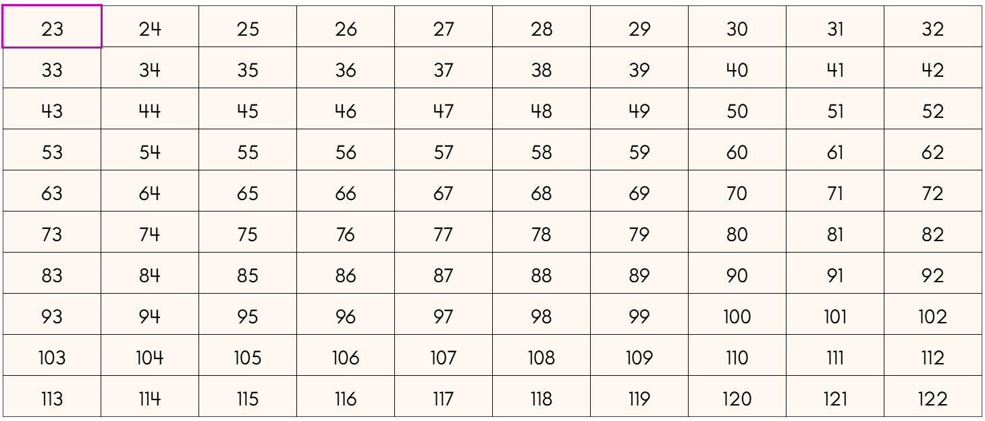

A number appears above the extended hundred square and the task is to press on where that number must be. For example, the task be to press where the number 81 would be.

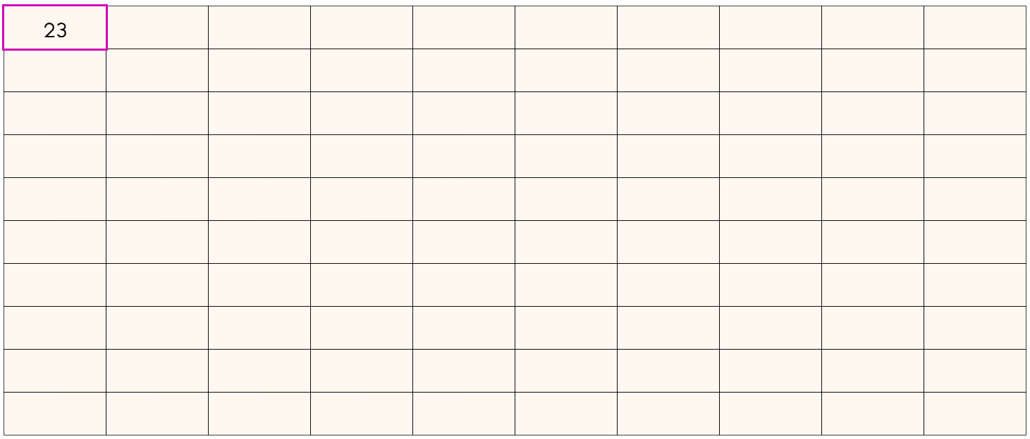

Pressing the  button will restart the activity with a new start number in the top-left and a new challenge number to find.

This activity can be done as a whole class, maybe with the class directing one student who then presses the square they think will have that number in.

An alternative idea is for there to be two (or more) teams, with each taking turns with the different start and target numbers.

A third idea would be to continue with the same start number. For example, after finding the first target number, say 81, press again on 81 and it will be hidden again. Then say a different number for them to find. This could also be done as a team game with each team saying a number for the other team to find (with a point given if they are successful). If the team says a number which is not in the overall extended hundred square, then they lose a point. A variation of this could be keeping each target number visible once found.

Teaching considerations:

One aim for this activity is for students to become aware of the structure of the grid, with the units digit increasing horizontally and the tens digit increasing vertically. An extra issue is that moving horizontally will sometimes result in moving from, for example, 79 to 80, with the tens digit changing and the units digit returning to zero. You may consider addressing this explicitly or allow students to become aware of this themselves.

It may be an idea to press on the right-hand of these buttons: . That will fill the extended hundred square with all the numbers and the students can get a sense of how the numbers are structured. Then, after they have got a sense of that, press on the left-hand button to hide all the numbers, and press on the top-left square to reveal the start number again. Then carry on with the task in the way you want to do so.

An alternative is to press on the middle of those three buttons. This will show a random selection of numbers. This can also help students to get a sense of the structure of the extended hundred square.

