Similar sums
Activity:

Two randomly chosen number squares are highlighted. The task is to click on two other squares whose numbers will add up to the same total as the original two highlighted numbers.

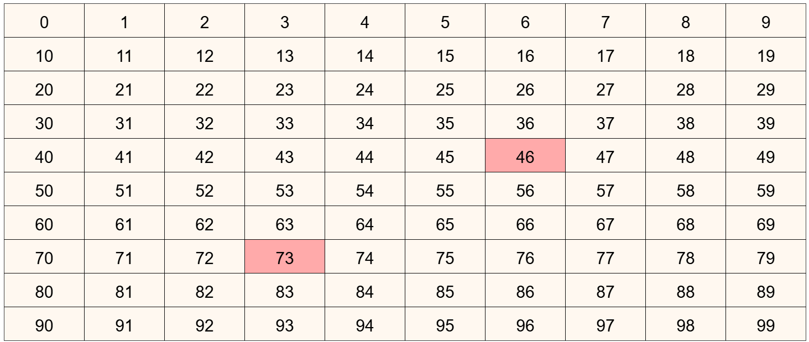

At first, students might add up the shaded tiles, 46+73, and think of two numbers which have the same total of 119 in this case.

Someone may realise that adding one on to 47, for example, and taking one off 73, will result in the same total. This can lead to many other suggestions, where it is not needed to add up 46 and 73 in the first place. For example, adding 50 onto 46 and taking 50 off 73 will also give the same total.

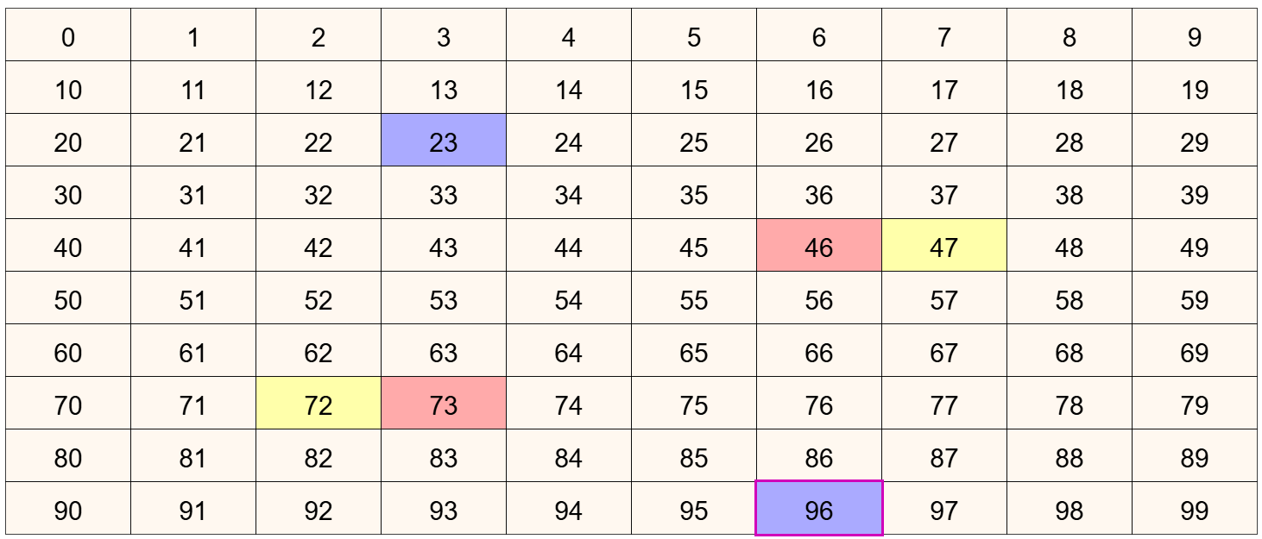

One idea is to ask for another pair, and another, and another… Gradually students might notice a symmetry in the squares highlighted. It will have a rotational symmetry about the midpoint between the original two highlighted squares.

Pressing the  button will restart the activity with two new, randomly chosen, highlighted squares.

Teaching considerations:

Ask the question why? Encourage students to explain why adding something to one number and taking the same off the other number will always end with the same total.

If students notice patterns in the highlighted squares, encourage them to describe the patterns as clearly as possible so that other students might notice them too. Consider using mathematical words of symmetry, rotation, half a whole turn, or even 180 degrees depending upon what is appropriate for those students.

Encourage generalisation. In algebraic terms, if the two start numbers are a and b, then $a+b=\left(a-n\right)+(b+n)$. This might be expressed in words. It is up to you if you feel it is appropriate to express in algebraic notation what had been expressed in words.

