Which number goes here?
Activity:

The task is for children to write down the number they think is in the highlighted square. Then the highlighted square is pressed and it will reveal the number in that square.

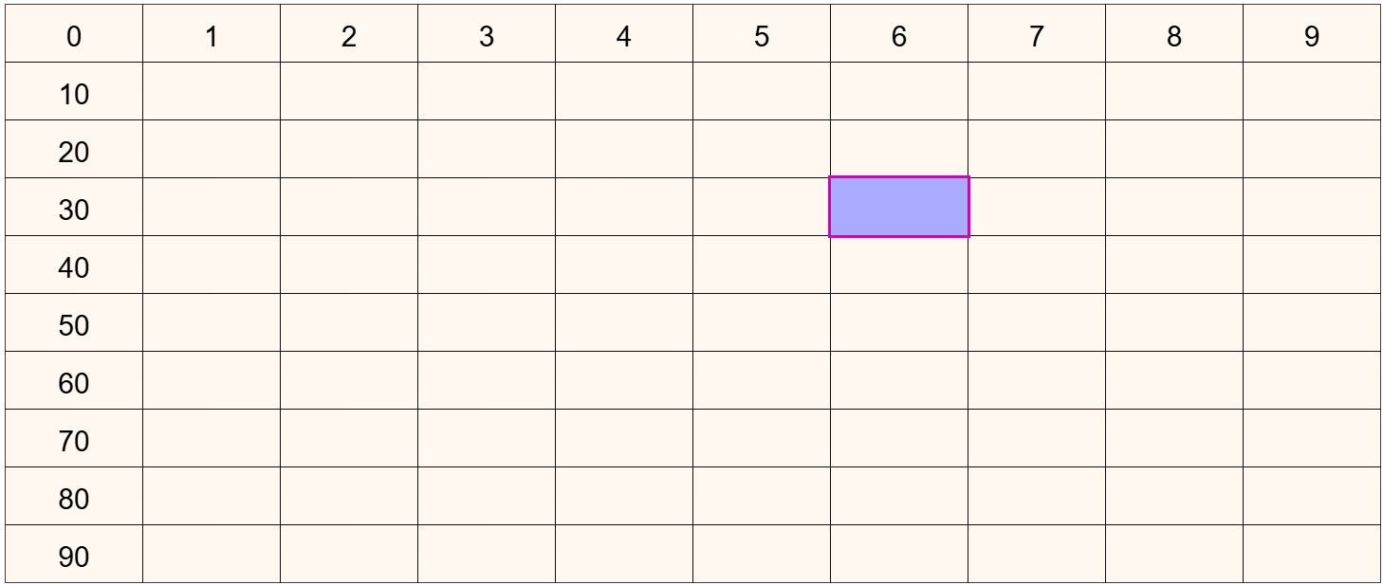

This activity could come after students have already seen the hundred square with all the number visible and noticed that all the numbers along the same row start with the same digit, and all numbers in the same column end with the same digit. This might be done with students looking at the numbers with no highlighting, or a row could be highlighted and students asked about what is the same and what is different within that row. Likewise with a column highlighted.

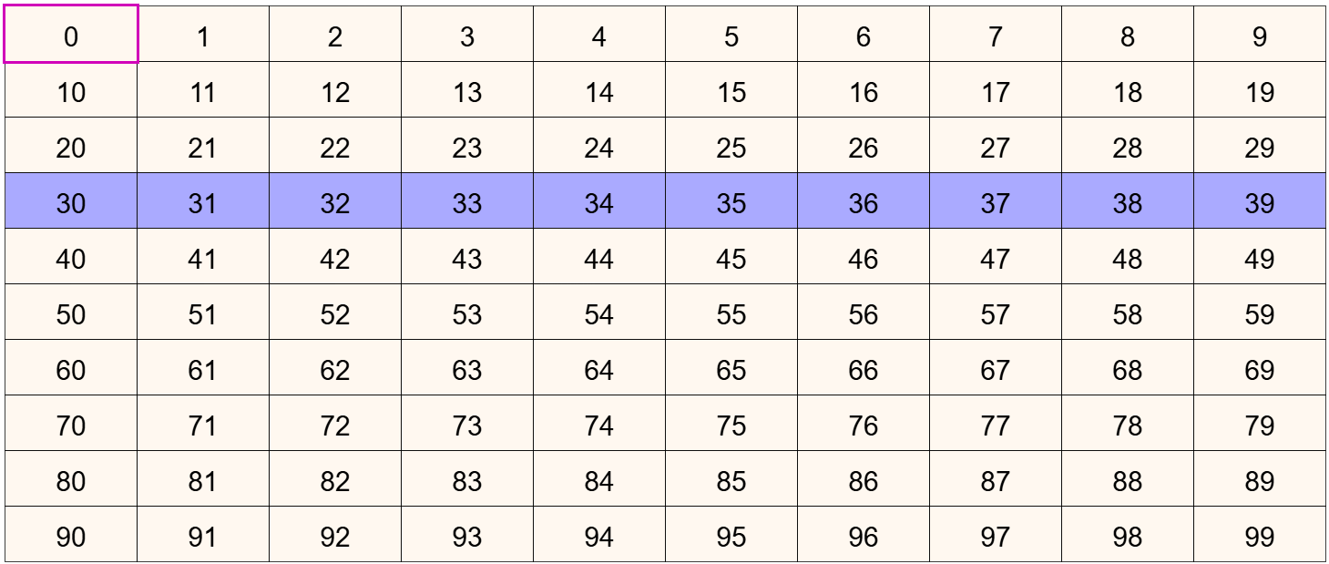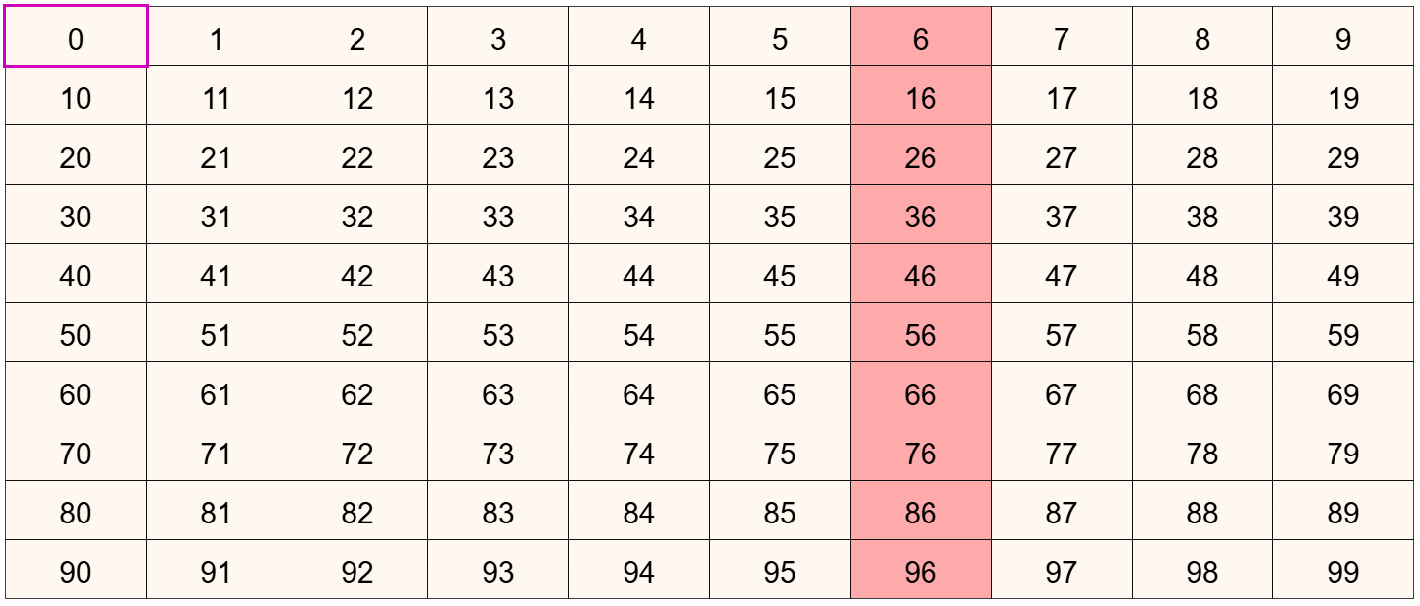

An alternative is to do this ‘Which number goes here?’ activity as a way of helping them notice how they can use the visible numbers in the top row and left column to work out which number should be in the highlighted square. They might start by guessing numbers and finding out that they were not correct. However, after trying this with several different highlighted squares, they might begin to notice how to work out what the number should be.

Pressing the  button will restart the activity with a new square highlighted.

Teaching considerations:

One aim for this activity is for students to become aware that a two-digit number is made up from a combination of a tens number (e.g. 30) and a units number (e.g. 6). The structure of the hundred square helps with seeing two-digit numbers as a combination of these two parts.

This can be shown more explicitly, once 36, for example, is already visible, by dragging the appropriate tens number horizontally until you get to the highlighted square. In the case below, it this case it will show 30+6 in that square. By pressing on the  button, the expression 30 + 6 = 36 will be shown above the hundred square. This indicates how the combination of those numbers is written.

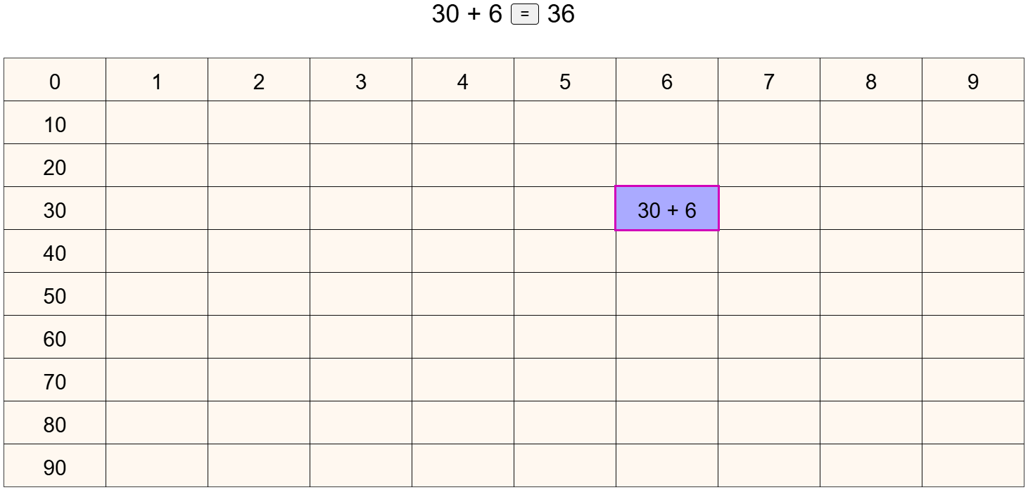

Note a common stage of learning how to write numbers is for students to write thirty six as 306. So learning how to write a two-digit number is an important step.

